SOBER CROWD CIC
Internal media posts for making sobriety support visible
Purpose | Provision of wording for social media posts to be used alongside the images provided in the toolkit.
Date issued / updated | 15 September 2026

COPY AND PASTE SUGGESTED WORDING BELOW AND USE WITH DOWNLOADED IMAGES FROM THE TOOLKIT
Awareness raising messaging to go with this image:
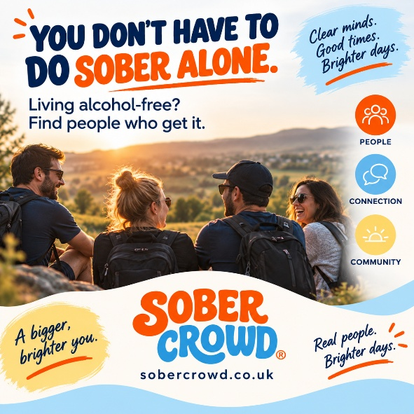
Suggested wording:
Living without alcohol doesn't mean having to navigate everything by yourself.
Sober Crowd connects people living alcohol-free through peer support, community and social opportunities.
If this could be useful to you or somebody you know, visit www.sobercrowd.co.uk.

Messaging to highlight Sober Crowd Newbury to go with this image:
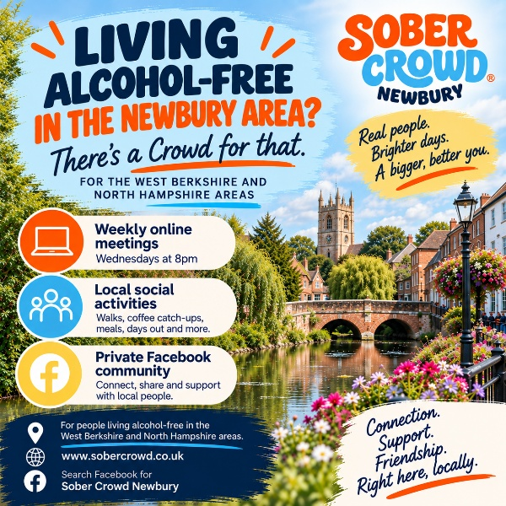
Suggested wording:
Sober Crowd Newbury is bringing local people living alcohol-free together for connection, support and friendship.
Online meetings take place on Wednesdays at 8pm, alongside regular local social activities, a private Facebook and WhatsApp group for daily connection.
Search Facebook for Sober Crowd Newbury or visit www.sobercrowd.co.uk.

